#SNPIM-120478 : **Eriez: Find the Alternative Way to Login into the Eriez Servers as we decomminsoed the N-able**

Servers on Nable

|  |  |  |  |  |
| --- | --- | --- | --- | --- |
| Eriez Manufacturing Company. | | | | |
| Name | Network Address | Device Class | License Mode | Virtual network/subnet |
| AP-BACK02 | 10.1.0.13 | Servers - Windows | Professional | EriezVirtualNetwork/default |
| AP-DC01 | 10.1.0.5 | Servers - Windows | Professional | EriezVirtualNetwork/default |
| AP-SYNC01 | 10.1.0.9 | Servers - Windows | Professional | EriezVirtualNetwork/default |
| AP-SYNC02 | 10.1.0.10 | Servers - Windows | Professional | EriezVirtualNetwork/default |
| APBACK01 | 10.1.0.11 | Servers - Windows | Professional | EriezVirtualNetwork/default |
| EriezAzureDFS | 10.1.0.14 | Servers - Windows | Professional | EriezVirtualNetwork/default |
| Sonic FIrewall | 192.168.0.7 | Switch/Router | Essential | Note- this Physical device has no Monitoring configured. |

Other devices on same Virtual network/subnet

|  |  |  |
| --- | --- | --- |
| Server | Network interface | IP Address |
| AP-NESSUS01 | ap-nessus01347 | 10.1.0.4 |
| AP-ORCH02 | ap-orch02151_z1 | 10.1.0.16 |
| AP-Scan01 | ap-scan01404_z1 | 10.1.0.12 |
| NIC not associated to VM | apdb01546 | 10.1.0.7 |

Next Action Plan- remove Nable agent from servers.

Account used by SNP- ERIEZUSA\snp

Eriez AVD assigned to SNP.

[AP-WVD-0.EriezUSA.net](https://portal.azure.com/)

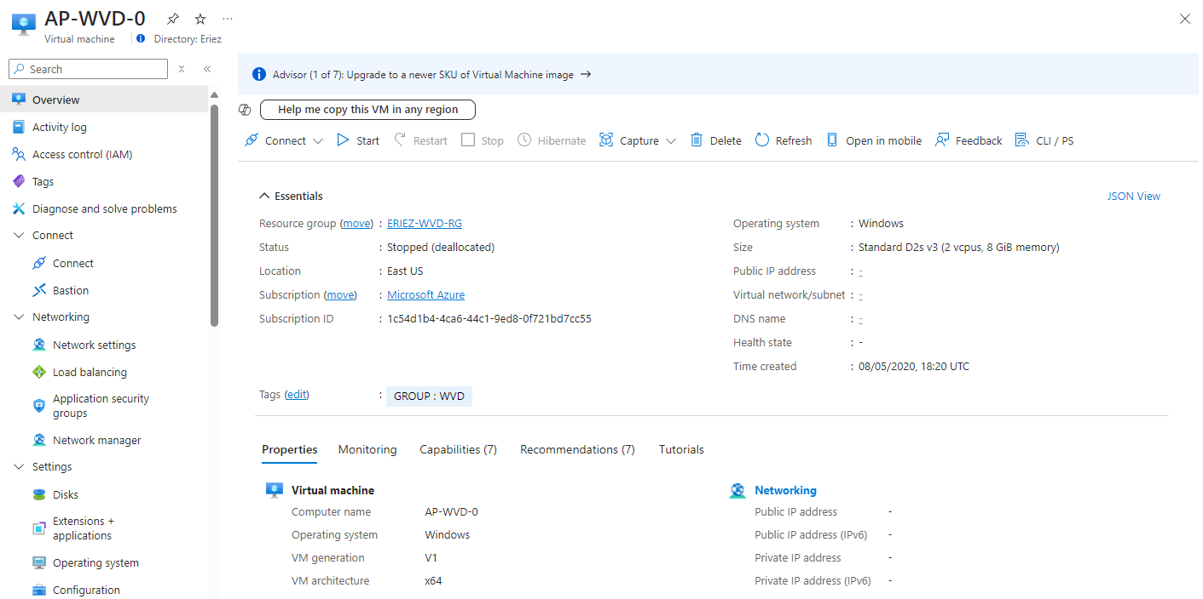

Existing Network–

[EriezVirtualNetwork/WVDSubnet](https://portal.azure.com/#blade/HubsExtension/ResourceMenuBlade/id/%2Fsubscriptions%2F1c54d1b4-4ca6-44c1-9ed8-0f721bd7cc55%2FresourceGroups%2FEriezHybridRG%2Fproviders%2FMicrosoft.Network%2FvirtualNetworks%2FEriezVirtualNetwork)

Able to take rdp to servers from AVD.

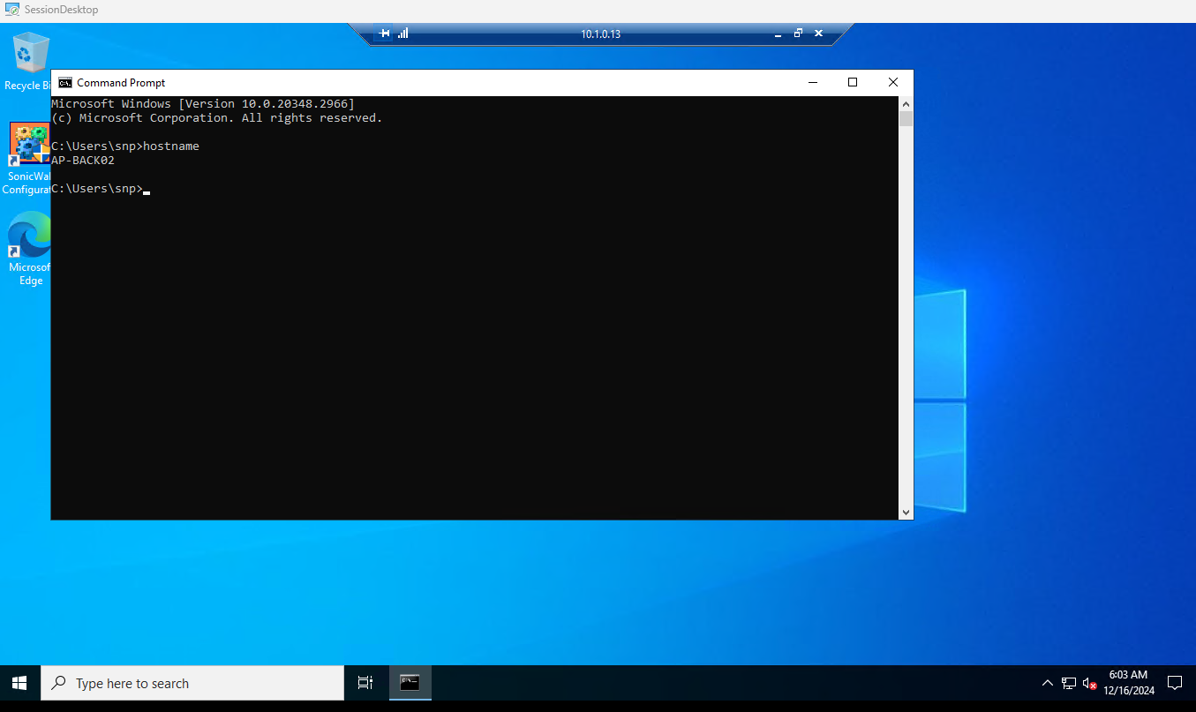

The subnet associated with servers which we need to connect is “default” subnet. And the subnet associated with a NSG called “Production_NSG”.

The NSG allow Inbound traffic from VNET.

As you are looking into more security and not allowing the rdp to all vms. We will follow below steps-

* .Next plan of action create a ASG assign servers need to connect from AVD.
* Block VNET default inbound rule.
* Create a new security rule to allow traffic from AVD to ASG

Additionally traffic is block to other servers and we are using SNP account which has very limited permissions to connect to limited servers.

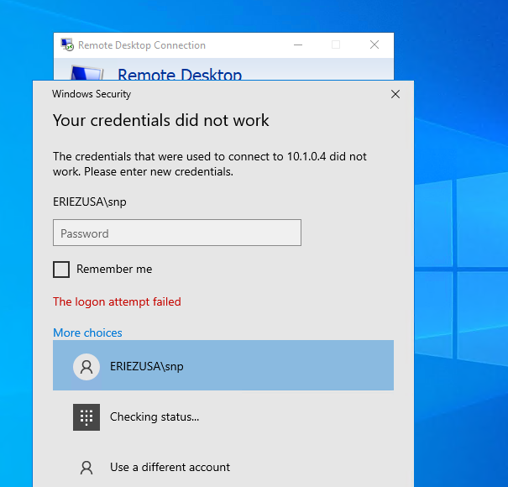

Client is using AVD for different purpose. so, alternative was looking for bastion.

Targeted to create bastion to have connection to other servers.

1. Difference between basic and standard bastion versions.

* **Instances**:
  + **Basic**: Comes with two instances by default.
  + **Standard**: Allows you to specify the number of instances, starting with a minimum of two
* **Features**:
  + **Basic**: Provides essential features for secure RDP/SSH connectivity to your virtual machines without needing a public IP address
  + **Standard**: Includes all Basic features plus additional capabilities like auto-scaling, support for multiple virtual networks, and enhanced security features
* **Pricing**:
  + **Basic**: Generally more cost-effective, priced at around $0.19 per hour
  + **Standard**: Slightly more expensive, priced at around $0.29 per hour

When Azure Bastion Basic SKU mentions "comes with two instances by default," it means that the Bastion deployment will automatically create and use two instances for handling connections. This setup ensures redundancy and availability.

These two instances are not a limit on the number of connections but rather the number of Bastion hosts running to manage the connections. You can have multiple users connecting to your virtual machines through these two instances simultaneously

Bastion diagram-

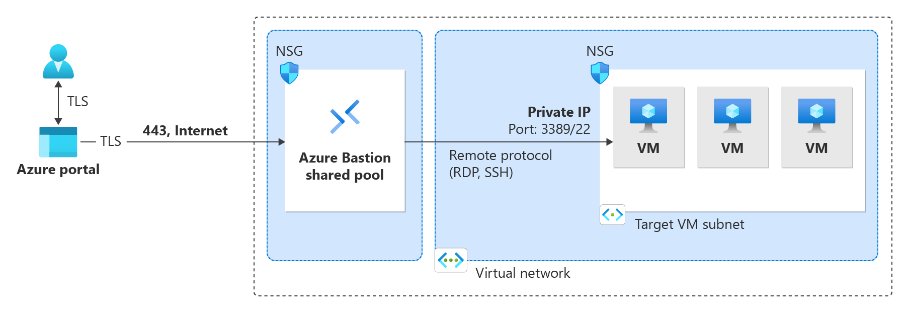

**Monthly cost- 146.78 USD**

Deployment any working-

1. Deploy Bastion subnet

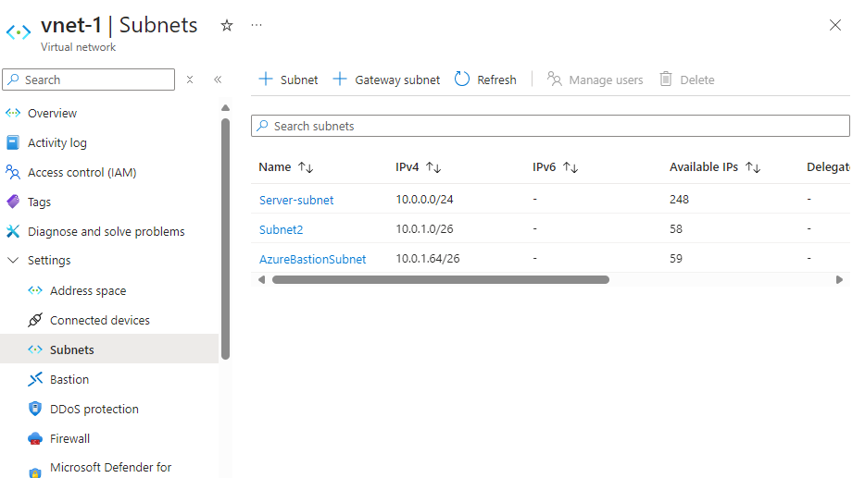

1. Deploy bastion

Connect to vm using bastion.

Connect to vm in different subnet.

Sessions-

Block other subnet vm connections.

Note- if we access servers on client environment by using bastion. This blocking traffic is totally optional. Because SNP user account has access to very limited servers. If we try to access other servers by using the same credentials login failed.

NSG applied on other subnets to archive same.

Subnet associated

Traffic block rule

Blocking traffic proof.

Vm in same subnet but not added in ASG

Servers in allowed subnet and added to ASG

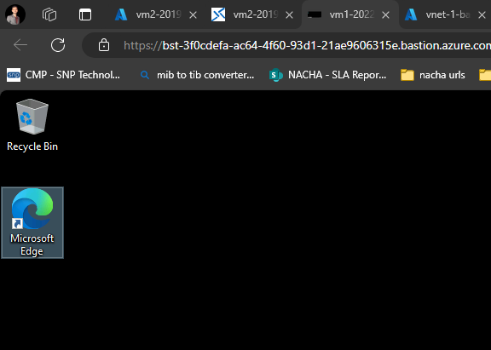

Diagram-

Have a separate RG for the new resource.

Create bastion for the targeted Vnet on new Subnet. (subnet will get create on the vnet RG)

Also create NSG ASG on new RG.

Those all does not even depend on VNET and Subnet.

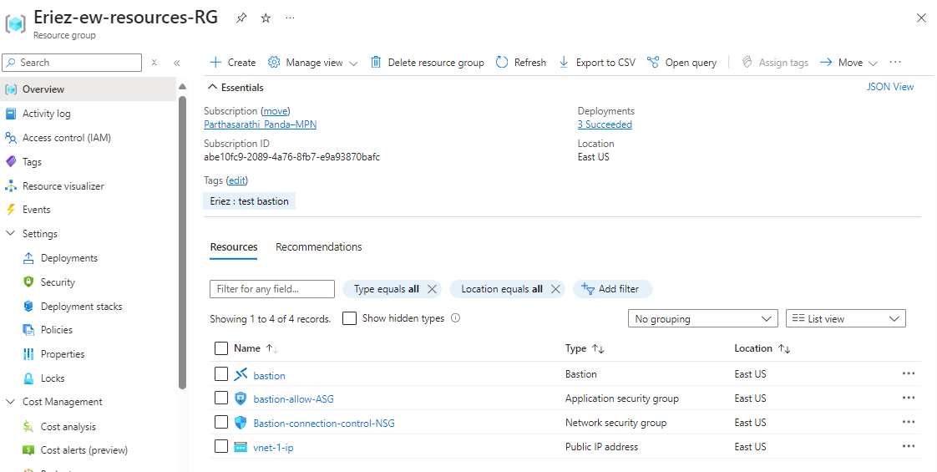

Do required config for NSG and ASG

It works.